Butterfly House Plans: Build A Butterfly House
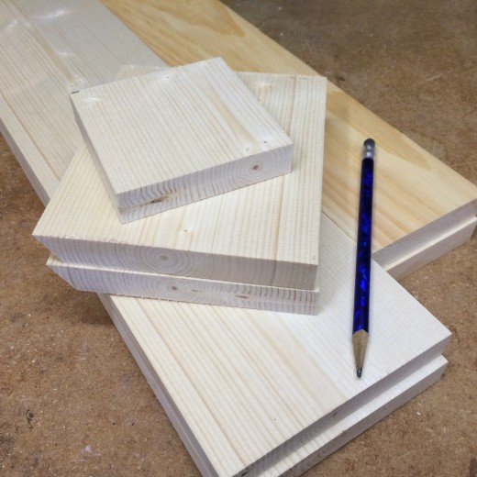
Source

The Cutting List
To make the box, start by cutting the boards to the following dimensions:
- Front: 22" long x 5" wide
- Back: 22" long x 5" wide
- Sides: 19" long x 3-½" wide (two pieces needed)
- Roof: 4" x 5-½" (two pieces needed)
- Bottom: 3-½" x 3-½"
- Mounting Block: 6" x 3" x 1-½"
The butterfly house is a basic box with a peaked roof. One side opens on a simple hinge, allowing access to the inside for cleaning or for mounting it to a post.
To cut the peaks for the roofline, mark the center of the front and back pieces. Lay out the 30 degree angles long one end of each piece. Cut along the marks to form the peaked ends.
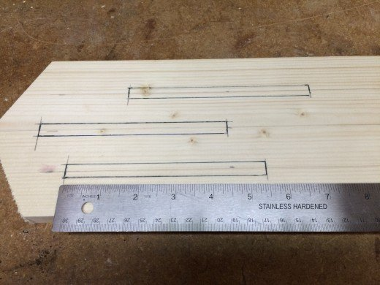
Source
Next, lay out the entrance slots on the front section. The butterfly box in the diagram (below) has six slots that are 5" long by 3/8" wide. The exact locations are not critical. I centered the middle slots, then laid out the locations for other slots in a pleasing pattern.
Using a 3/8" drill bit, drill a hole at each end of the slot. Then use a jig saw to cut out the rest of the slot. Smooth out any rough spots with a file.
Cut one edge of the roof sections at a 30 degree angle to match the peaks on the front and back pieces. Fitted together, the 30 degree cuts on the roof sections form the peaked roof.
I stained and painted the pieces before beginning the final assembly. The front piece is painted red, and the roof sections are stained ebony black. The rest of the pieces were stained white. Only the exterior was painted or stained.
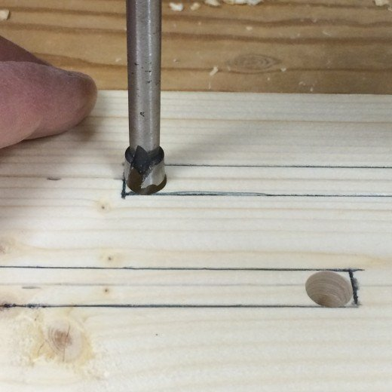
Source

Some Assembly Required
Begin the assembly by attaching the front to one of the side pieces with exterior screws or nails. Align the bottom edges of both pieces before securing them together.
Attach the bottom to the front and side assembly, and then attach the back section.
Line up the remaining side with the bottom of the front and back pieces. To create a hinged door, secure the side section to the front assembly with one nail or screw driven into edge approximately 1" down from the top.
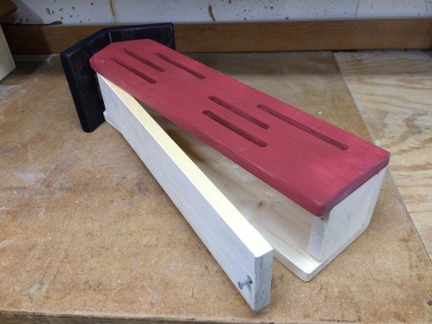
Then, finish the hinged side by driving one nail or screw one through the back to form a pivot point. Position the hinge nails or screws in the front and back sections directly across from each other, enabling the door to open easily (refer to the side view drawing).

Source
Drill and countersink a screw hole along the center of the bottom edge of the hinged door. A single short screw will secure the door, yet allow easy access to the butterfly boxes for cleaning.
Position the roof sections by attaching the pieces to the front and back sections. Do not nail the roof pieces to the side section which forms the hinged door. The butterfly box is ready for the garden, or for some brightly colored paint.
Mount the finished garden butterfly box to a post in the garden. To use a section of ¾" copper pipe as a post, attach a small piece wood (approximately 6" long x 3" wide x 1-½" thick) to the inside of the butterfly house, securing it from the back with a couple of nails or screws. Drill a ¾" hole though the bottom and into the block, and then mount the butterfly box on to a section of copper pipe.

Butterfly House Plans:
